

**UNIVERSITI MALAYSIA TERENGGANU**

**CSM3023 – WEB PROGRAMMING 2**

**BACHELOR OF COMPUTER SCIENCE (MOBILE COMPUTING) WITH HONORS**

**LAB 4 – JSP: Scriptlet, Expression & Standard Actions**

**SEMESTER II 2023/2024**

**Prepared for:**

DR MOHAMAD NOR BIN HASSAN

**Prepared by:**

MUHAMMAD ARIF HAIKAL BIN SALLEHUDDIN

(S66355)

Link Github :

<https://github.com/arifhaikal2001/CSM3023-LAB-4.git>

**Task 1: Using JSP Scripting**

Code :

customer.html

|  |
| --- |
| <!DOCTYPE html>  <html>  <head>  <title>Using JSP Scripting</title>  <meta charset="UTF-8">  <meta name="viewport" content="width=device-width, initial-scale=1.0">  </head>  <body>  <h1>Use JSP Scriptlet and JSP Expression in Application</h1>  <h2 style="color: #B95CF4;">Customer discount</h2>  <form action="processCustomer.jsp" method="post">  <label for="customer_code">Customer Code:</label>  <input type="number" id="customercode" name="customer_code" placeholder="Key-in customer code" required><br><br>  <label for="quantity">Quantity:</label>  <input type="number" id="quantity" name="quantity" placeholder="Key-in quantity" required><br><br>  <label>Customer Type:</label>  <ul id="custtype" name="cust_type" required>  <input type="radio" id="1" name="cust_type" value="1" required><label for="normal">Normal Customer</label>  <input type="radio" id="2" name="cust_type" value="2" required><label for="privilege">Privilege Customer</label>  </ul>  <button type="submit">Submit</button>  <button type="reset">Cancel</button>  </form>  <br><br>  </body>  <footer>  &copy;2024 ARIF HAIKAL  </footer>  </html> |

processCustomer.jsp

|  |
| --- |
| <%--  Document : processCustomer  Created on : 28 Apr 2024, 11:07:18 pm  Author : ARIF HAIKAL  --%>  <%@page contentType="text/html" pageEncoding="UTF-8"%>  <!DOCTYPE html>  <html>  <head>  <meta http-equiv="Content-Type" content="text/html; charset=UTF-8">  <title>Using JSP Scripting</title>  </head>  <body>  <h1>Use JSP Scriptlet and JSP Expression in application</h1>  <%  final int price = 10;  String customerCode = request.getParameter("customer_code");  int quantity = Integer.parseInt(request.getParameter("quantity"));  String customerType = request.getParameter("cust_type");  if (customerType.equals("1") && quantity > 100){  out.print("<p>You're entitled to a 10% discount</p>");  out.print("<p>Total amount is RM" + quantity * price * 0.9 + "</p>");  }  else if (customerType.equals("2") && quantity > 100) {  out.print("<p>You're entitled to a 25% discount</p>");  out.print("<p>Total amount is RM" + quantity * price * 0.75 + "</p>");  }  else {  out.print("<p>You're not entitled to a discount..!</p>");  out.print("<p>Total amount is RM" + quantity * price + "</p>");  }  %>  <br><br>  </body>  <footer>  &copy;2024 ARIF HAIKAL  </footer>  </html> |

Output :

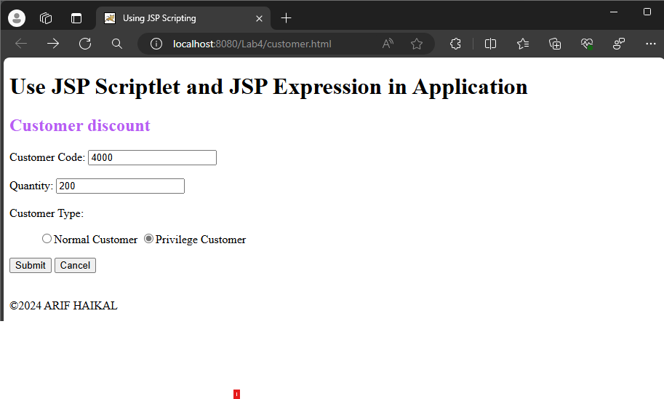

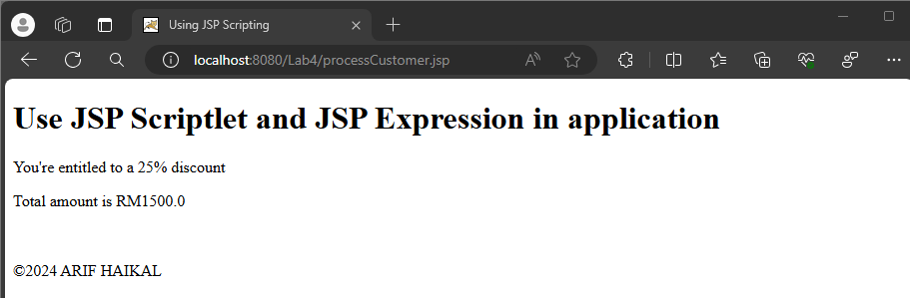

**Reflection**

1. What you have learnt from this exercise?

* I learnt about to create dynamic webpage using JSP.

2. Explain three (3) type of JSP scripting?

* Scriptlets
* Declarations
* Expressions

**Task 2: Using JSP (Scripting, Declaration and Expression)**

Code :

currencyConversion.html

|  |
| --- |
| <!DOCTYPE html>  <html>  <head>  <title>Currency Conversion</title>  <meta charset="UTF-8">  <meta name="viewport" content="width=device-width, initial-scale=1.0">  </head>  <body>  <h1>Use JSP Declaration tag, JSP Scriplet and JSP Expression in application</h1>  <h2 style="color: #B95CF4;">Currency Conversion</h2>    <form action="processCurrency.jsp" method="post">  <label for="amount">Amount(in RM) :</label>  <input type="number" id="amount" name="amount" placeholder="RM"required><br><br>  <label for="convert">Convert to :</label>  <select id="convert" name="convert" required>  <option value="1">USD</option>  <option value="2">STG</option>  <option value="3">Euro</option>    <button type="submit">Submit</button>  <button ty[e="clear">Cancel</button>  </select><br><br>    <input type="submit" id="btnSubmit" value="Submit"/>  <input type="reset" id="btnCancel" value="Cancel"/>  <br><br>  </body>  <footer>  &copy;2024 ARIF HAIKAL  </footer>  </html> |

processCurrency.jsp

|  |
| --- |
| <%--  Document : processCurrency  Created on : 30 Apr 2024, 2:29:06 am  Author : ARIF HAIKAL  --%>  <%@page contentType="text/html" pageEncoding="UTF-8"%>  <!DOCTYPE html>  <html>  <head>  <meta http-equiv="Content-Type" content="text/html; charset=UTF-8">  <title>Currency Conversion</title>  </head>  <body>  <%!  final double USD = 3.92;  final double STG = 5.96;  final double EURO = 4.47;  private double calculateRate(String currency, int amount) {  double currencyChange = 0.00;  if (currency.equals("1"))  currencyChange = (double) (amount / USD);  else if (currency.equals("2"))  currencyChange = (double) (amount / STG);  else if (currency.equals("3"))  currencyChange = (double) (amount / EURO);  return currencyChange;  }  %>    <%  int amount = Integer.parseInt(request.getParameter("amount"));  String convertTo = request.getParameter("convert");  double result = calculateRate(convertTo, amount);  %>    <h1>Use JSP Scriplet and JSP Expression in application</h1>  <p style="color: purple;">Amount in Ringgit Malaysia: RM<%= amount %></p>  <% if (convertTo.equals("1")) { %>  <p style="color: purple;">Amount in US Dollar: <%= String.format("%.2f", result) %></p>  <% } else if (convertTo.equals("2")) { %>  <p style="color: purple;">Amount in British Pound: <%= String.format("%.2f", result) %></p>  <% } else if (convertTo.equals("3")) { %>  <p style="color: purple;">Amount in Euro: <%= String.format("%.2f", result) %></p>  <% } %>    </body>  <footer>  &copy;2024 ARIF HAIKAL  </footer>  </html> |

Output :

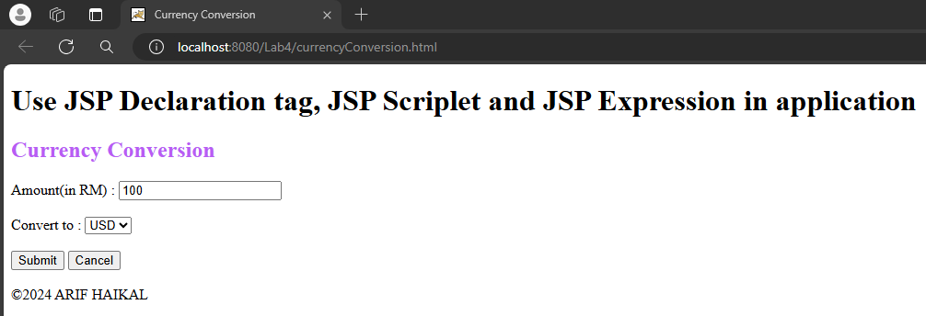

* In USD

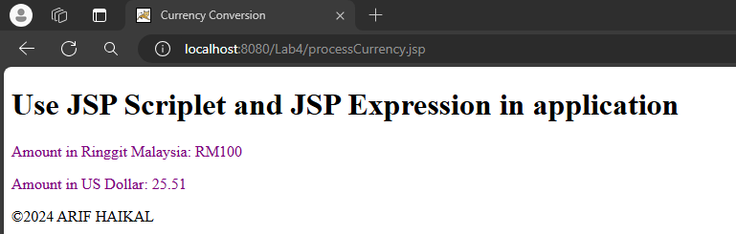

* In British Pound

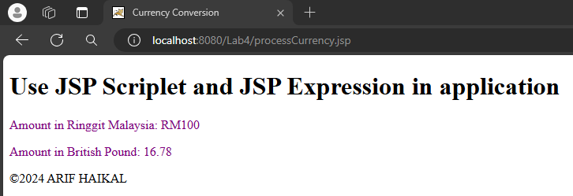

* In Euro

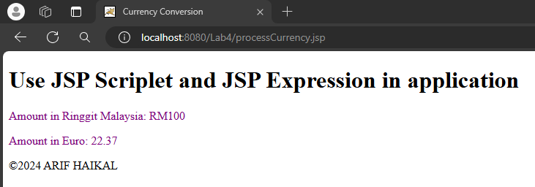

**Reflection**

1. What have you learn from this exercise?

* Create basic web using JSP including scriplets to handle form submissions and perform calculations.

**Task 3: Using JSP Standard Action (Include and Param)**

Code :

jspParameter.jsp

|  |
| --- |
| <%--  Document : jspParameter  Created on : 30 Apr 2024, 3:12:38 am  Author : ARIF HAIKAL  --%>  <%@page contentType="text/html" pageEncoding="UTF-8"%>  <!DOCTYPE html>  <html>  <head>  <meta http-equiv="Content-Type" content="text/html; charset=UTF-8">  <title>Using JSP Standard Action</title>  </head>  <body>  <h1>Using jsp:include and jsp:param to display information on JSP page</h1>    <%  String sCode = "CSM3223";  String sSubject = "Web Programming 2";  String sCredit = "3(2+1)";  %>    <jsp:include page="subjectInfo.jsp" flush="true">  <jsp:param name="code" value="<%=sCode%>"/>  <jsp:param name="subject" value="<%=sSubject%>"/>  <jsp:param name="credit" value="<%=sCredit%>"/>  </jsp:include>  <br>  </body>  <footer>  &copy;2024 ARIF HAIKAL  </footer>  </html> |

subjectInfo.jsp

|  |
| --- |
| <%--  Document : subjectInfo  Created on : 30 Apr 2024, 3:14:41 am  Author : ARIF HAIKAL  --%>  <%@page contentType="text/html" pageEncoding="UTF-8"%>  <!DOCTYPE html>  <html>  <head>  <meta http-equiv="Content-Type" content="text/html; charset=UTF-8">  <title>Using JSP Standard Action</title>  </head>  <body>  <h1>Calling subjectInfo.jsp page</h1>  <p>Code = <%=request.getParameter("code")%></p>  <p>Subject = <%=request.getParameter("subject")%></p>  <p>Credit = <%=request.getParameter("credit")%></p>  </body>  </html> |

Output :

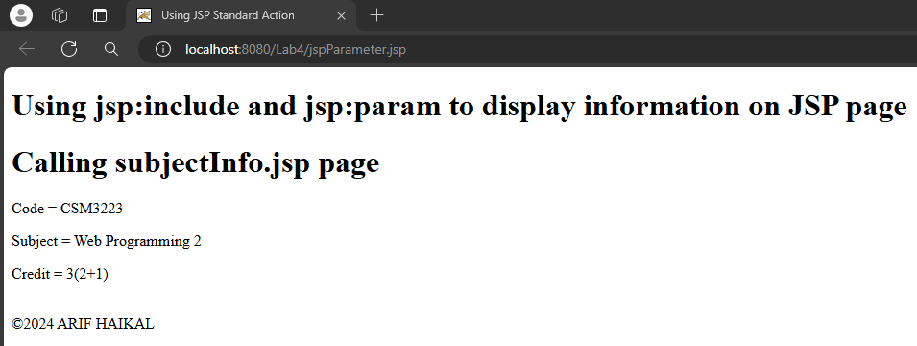

**Reflection**

1. What you have learnt from this exercise?

* How to use <jsp:include> and <jsp:param> to include content from one JSP file into another and pass parameters.

1. List TWO (2) other JSP Standard Action Tag.

* <jsp:forward>
* <jsp:useBean>

**Task 4: Using JSP Standard Action (Forward)**

Code :

forward.jsp

|  |
| --- |
| <%--  Document : forward  Created on : 30 Apr 2024, 3:38:19 am  Author : ARIF HAIKAL  --%>  <%@page contentType="text/html" pageEncoding="UTF-8"%>  <!DOCTYPE html>  <html>  <head>  <meta http-equiv="Content-Type" content="text/html; charset=UTF-8">  <title>Using JSP Standard Action(forward)</title>  <style>  footer {  text-align: center;  }  </style>  </head>  <body>  <h2>Using jsp:forward to display user info.</h2>  <jsp:forward page="forwardInfo.jsp">  <jsp:param name="U_Name" value="ARIF HAIKAL"/>  <jsp:param name="Email" value="S66355@ocean.umt.edu.my"/>  <jsp:param name="Nationality" value="Malaysia"/>  <jsp:param name="Background" value="UMT Student"/>  </jsp:forward>  </body>  <footer>  &copy;2024 ARIF HAIKAL  </footer>  </html> |

forwardInfo.jsp

|  |
| --- |
| <%--  Document : forwardInfo  Created on : 30 Apr 2024, 3:45:13 am  Author : ARIF HAIKAL  --%>  <%@page contentType="text/html" pageEncoding="UTF-8"%>  <!DOCTYPE html>  <html>  <head>  <meta http-equiv="Content-Type" content="text/html; charset=UTF-8">  <title>&lt;Forwarded_Action Example in JSP&gt;</title>  <style>  footer {  text-align: center;  }  </style>  </head>  <body>  <% String name = request.getParameter("U_Name"); %>  <% String Email = request.getParameter("Email"); %>  <% String Nationality = request.getParameter("Nationality"); %>  <% String Background = request.getParameter("Background"); %>  <% if (name != null) {%>  <br><br><br><h2 align="center">    <%=name%><br>  <%=Email%><br>  <%=Nationality%><br>  <%=Background%><br><br>    <% out.print("Today is:" + java.util.Calendar.getInstance().getTime());%>  <h2></b></br>  <%}%>  </body>  <footer>  &copy;2024 ARIF HAIKAL  </footer>  </html> |

Output :

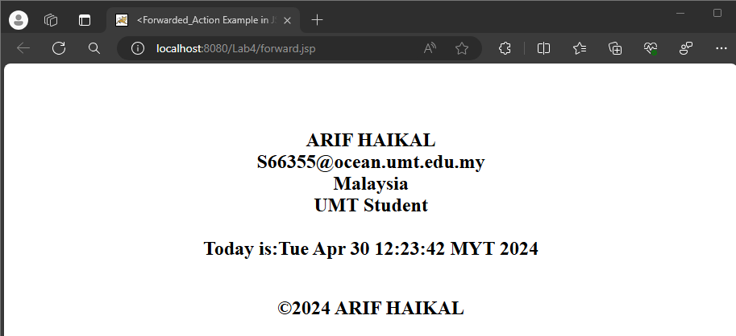

**Reflection**

1. What you have learnt from this exercise?

* How to use JSP to forward a request from JSP to the another JSP.

1. List TWO(2) More JSP Standard Action Tag.

* <jsp:useBean>
* <jsp:setProperty>

**Task 5: Use Java Scriptlet To Construct Business Logic**

Code :

insuranceQuotation.jsp

|  |
| --- |
| <%--  Document : insuranceQuotation  Created on : 30 Apr 2024, 10:56:26 am  Author : ARIF HAIKAL  --%>  <%@page contentType="text/html" pageEncoding="UTF-8"%>  <!DOCTYPE html>  <html>  <head>  <meta http-equiv="Content-Type" content="text/html; charset=UTF-8">  <title>Insurance Quotation</title>    <script>  function validateForm() {  let icno = document.getElementById("icno").value;  let name = document.getElementById("name").value;  let price = document.getElementById("price").value;  if(icno === "" || name === "" || price === "") {  alert("Please fill in all fields");  return false;  }  return true;  }  </script>    </head>  <body>  <h1>Insurance Quotation</h1>  <form action="processInsuranceQuo.jsp" onsubmit="return validateForm()">  <fieldset>  <legend>Insurance Calculation</legend>    <label for="icno">ICNo :</label>  <input type="number" id="icno" name="icno"><br><br>    <label for="name">Name :</label>  <input type="text" id="name" name="name"><br><br>    <label for="price">Market Price :</label>  <input type="number" id="price" name="price"><br><br>    <label for="cover">Coverage Type:</label>  <select name="cover" id="cover">  <option value="1" selected="selected">Comprehensive</option>  <option value="2">Third-party</option>  </select><br><br>    <label for="disc">No claims discount(NCD):</label>  <select name="disc" id="disc">  <option value="1" selected="selected">10%</option>  <option value="2">25%</option>  <option value="3">35%</option>  <option value="4">55%</option>  </select><br><br>    <button type="submit">Submit</button>  <button type="reset">Cancel</button>  </fieldset>  <br>  </body>  <footer>  &copy;2024 ARIF HAIKAL  </footer>  </html> |

processInsuranceQuo.jsp

|  |
| --- |
| <%--  Document : processInsuranceQuo  Created on : 30 Apr 2024, 10:56:42 am  Author : ARIF HAIKAL  --%>  <%@page contentType="text/html" pageEncoding="UTF-8"%>  <!DOCTYPE html>  <html>  <head>  <meta http-equiv="Content-Type" content="text/html; charset=UTF-8">  <title>Details Insurance</title>  </head>  <body>  <%  String icNo = request.getParameter("icno");  String customerName = request.getParameter("name");  double marketPrice = Double.parseDouble(request.getParameter("price"));  String coverageType = request.getParameter("cover");  int ncd = Integer.parseInt(request.getParameter("disc"));  double discount = 0.0;  switch (ncd) {  case 1:  discount = 0.1;  break;  case 2:  discount = 0.25;  break;  case 3:  discount = 0.35;  break;  case 4:  discount = 0.55;  break;  }  double totalAmount = marketPrice * (1 - discount);  double gst = totalAmount * 0.06;  double finalAmount = totalAmount + gst;  %>    <fieldset>  <legend><h3>Details of Insurance Quotation</h3></legend>  <p style="color: #7D0DC3;">IC No: <%= icNo %></p>  <p style="color: #7D0DC3;">Customer Name: <%= customerName %></p>  <p style="color: #7D0DC3;">Market Price: <%= marketPrice %></p>  <p style="color: #7D0DC3;">Coverage Type: <%= (coverageType.equals("1")) ? "Comprehensive" : "Third-party" %></p>  <p style="color: #7D0DC3;">No Claim Discount (NCD): <%= (discount * 100) %>%</p>  <p style="color: #7D0DC3;">Insurance Amount: <%= totalAmount %></p>  <p style="color: #7D0DC3;">6% GST: <%= gst %></p>  <p style="color: #7D0DC3;"><strong>Final Amount (with 6% GST): <%= finalAmount %></strong></p>  </<fieldset>  </body>  </html> |

Output :

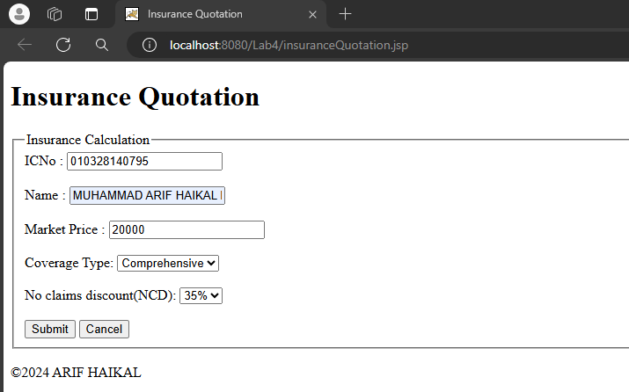

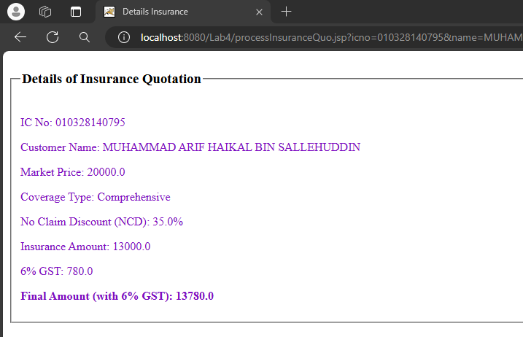

**Reflection**

1. What you have learnt from this exercise?

* How to create a web form for insurance quotation using HTML and JavaScript for client-side validation

2. List all Java features you used in Java Scriptlet.

* Java expressions
* Declarations
* Scriptlets for dynamic content generation

**Exercise**

Code :

bmiCalculator.jsp

|  |
| --- |
| <%--  Document : bmiCalculator  Created on : 30 Apr 2024, 11:30:54 am  Author : ARIF HAIKAL  --%>  <%@page contentType="text/html" pageEncoding="UTF-8"%>  <!DOCTYPE html>  <html>  <head>  <meta http-equiv="Content-Type" content="text/html; charset=UTF-8">  <title>BMI Calculator</title>  </head>  <body>  <h1>BMI Calculator</h1>    <form method="post" action="bmiCalculated.jsp">  Enter your weight in kilograms: <input type="text" name="weight"><br>  Enter your height in meters: <input type="text" name="height"><br>  <input type="submit" value="Calculate BMI">  </form>  <br>  </body>  <footer>  &copy;2024 ARIF HAIKAL  </footer>  </html> |

bmiCalculated.jsp

|  |
| --- |
| <%--  Document : bmiCalculated  Created on : 30 Apr 2024, 11:30:02 am  Author : ARIF HAIKAL  --%>  <%@page contentType="text/html" pageEncoding="UTF-8"%>  <%@ page import="java.text.DecimalFormat" %>  <%@ page import="java.io.PrintWriter" %>  <!DOCTYPE html>  <html>  <head>  <meta http-equiv="Content-Type" content="text/html; charset=UTF-8">  <title>BMI Calculated</title>  </head>  <body>  <h1>BMI Calculated</h1>    <%  double weight = Double.parseDouble(request.getParameter("weight"));  double height = Double.parseDouble(request.getParameter("height"));  double bmi = weight / (height * height);  String bmiCategory;  if (bmi < 18.5) {  bmiCategory = "underweight";  } else if (bmi >= 18.5 && bmi <= 25) {  bmiCategory = "optimal weight";  } else {  bmiCategory = "overweight";  }  DecimalFormat df = new DecimalFormat("#.##");  String bmiFormatted = df.format(bmi);  %>    <p>Your BMI is: <%= bmiFormatted %></p>  <p>You are <%= bmiCategory %>.</p>  </body>  <footer>  &copy;2024 ARIF HAIKAL  </footer>  </html> |

Output :

